**Q1**. Consider the following code snippet.

if (aNumber >= 0)

if (aNumber == 0)

System.out.println("first string");

else

System.out.println("second string");

System.out.println("third string");

1. **Exercise:** What output do you think the code will produce if aNumber is 3?

ans-second string

third string

### Q2. How Old Are You?

Make a program which displays a different message depending on the age given. Here are the possible responses:

* age is less than 16, say "You can't drive."
* age is less than 18, say "You can't vote."
* age is less than 25, say "You can't rent a car."
* age is 25 or over, say "You can do anything that's legal."

Here's a sample run. Notice that a person who is under 16 will display *three* messages, one for being under 16, one for also being under 18, and one for also being under 25.

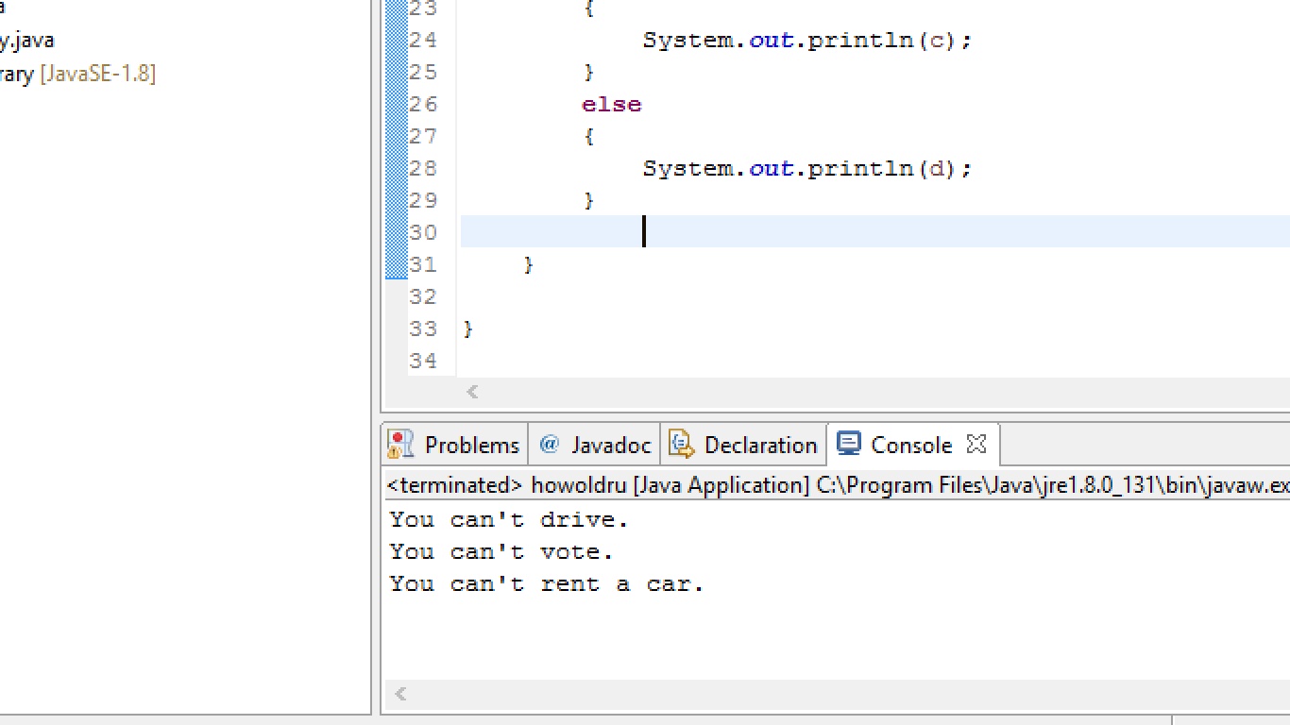

### Q3. Weekday Name

I have provided a function that is supposed to return the name of a day of the week given the day number.

#### Files Needed

* [WeekdayName.java](https://programmingbydoing.com/a/examples/WeekdayName.java)

Use if and else to complete it according to the following table:

|  |  |
| --- | --- |
| **Number** | **Day of week** |
| 1 | Sunday |
| 2 | Monday |
| 3 | Tuesday |
| 4 | Wednesday |
| 5 | Thursday |
| 6 | Friday |
| 7 | Saturday |
| 0 | Saturday |
| anything else | "error" |

**Q4.** What is the output of this program?

1. class selection_statements {
2. public static void main(String args[])
3. {
4. int var1 = 5;
5. int var2 = 6;
6. if ((var2 = 1) == var1)
7. System.out.print(var2);
8. else
9. System.out.print(++var2);
10. }
11. }

a) 1  
b) 2  
c) 3  
d) 4  
ans-2

reason-though var2 is a global variable but inside if else statement its value has been defined locally n so it is given priority and so output is 2

**Q5.** What is the output of this program?

1. class comma_operator {
2. public static void main(String args[])
3. {
4. int sum = 0;
5. for (int i = 0, j = 0; i < 5 & j < 5; ++i, j = i + 1)
6. sum += i;
7. System.out.println(sum);
8. }
9. }

a) 5  
b) 6  
c) 14  
d) compilation error

ans-6

**Q6.** What is the output of this program?

1. class jump_statments {
2. public static void main(String args[])
3. {
4. int x = 2;
5. int y = 0;
6. for ( ; y < 10; ++y) {
7. if (y % x == 0)
8. continue;
9. else if (y == 8)
10. break;
11. else
12. System.out.print(y + " ");
13. }
14. }
15. }

a) 1 3 5 7  
b) 2 4 6 8  
c) 1 3 5 7 9  
d) 1 2 3 4 5 6 7 8 9

ans-1 3 5 7 9

**Q7.** What is the output of this program?

1. class Output {
2. public static void main(String args[])
3. {
4. final int a=10,b=20;
5. while(a<b)
6. {
8. System.out.println("Hello");
9. }
10. System.out.println("World");
12. }
13. }

a) Hello  
b) run time error  
c) Hello world  
d) compile time error

ans-run time error

reason-value of a is not incremented ,so here it goes infinite loop n thus shows run time error.

**Q8.** What is the output of this program?

1. class Output {
2. public static void main(String args[])
3. {
4. int a = 5;
5. int b = 10;
6. first: {
7. second: {
8. third: {
9. if (a == b >> 1)
10. break second;
11. }
12. System.out.println(a);
13. }
14. System.out.println(b);
15. }
16. }
17. }

a) 5 10  
b) 10 5  
c) 5  
d) 10

**Q9.** What will be the output of following program?

|  |
| --- |
| public class temp  {      public static void main(String agrs[])      {          for(int i=1; i<=10; i++);          System.out.print(i);      }  } |

1. 12345678910
2. 11
3. Error
4. 1 2 3 4 5 6 7 8 9 10

ans-error

reason-i is not defined globally and it is not considered as a global variable and it is a local variable while the output is written for global variable , thus the program shows an error.

**Q.10** What will be the output of following program?

|  |
| --- |
| public class temp  {      public static void main(String agrs[])      {          int i;          for(i=1; i<=10; i++);          System.out.print(i);      }  } |

1. 12345678910
2. 11
3. Error
4. 1 2 3 4 5 6 7 8 9 10

ans-11

reason-value of i will be incremented again n again because there is blank statement under for loop n as i is defined variable so its value will printed which is 11.